BY FLORENCE ADEWUNMI
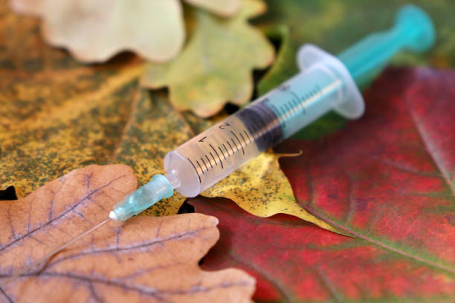  Welling Medical Practice Newsletter AUTUMN 2024  Summer seems to have flown by, and autumn is upon us once again. Eligible patients should have now received their invitations for both the Flu Vaccination and the Autumn Covid-19 booster.  NHS England has advised that these vaccines should be administered together, making it more convenient for you with just one appointment for both vaccinations.  Please do not attend the practice for your vaccination if you do not have an appointment scheduled for 5th or 6th October 2024.  The flu vaccination programme for all children aged 2-3 years has begun. Children born between 1st September 2020 - 31st August 2022 are eligible to receive the Fluenz nasal spray, which protects against flu this autumn/winter. All eligible children’s parents would have received an invitation via text message, with a link to book the appointment directly. If you haven’t yet booked and your child falls into this age group, please contact the surgery to arrange a Fluenz appointment.  All school-aged children (from reception to year 11) will be offered the Fluenz vaccine at school. If your child is home-schooled, please contact the surgery to book an appointment.  Any under-18s outside of this group, who are in a clinical risk group (e.g. asthmatic, diabetic, etc.), are also eligible to receive their vaccination at the practice. | Pharmacy First scheme  In February 2024 the government launched Pharmacy First, scheme that enables community pharmacies to deliver consultations and potentially provide prescription only medications for 7 common conditions following defined clinical pathways.  The new service allows more convenient access to safe and high-quality healthcare, reduce the demand on GP surgeries and reduce delays in treatment.  It is a new service and there are limitations to it but it’s the first step on a road to recovery for primary care and has potential to be of huge benefit to patients both at the present time and in the future as well.  Conditions that are treated & Age range  - Acute otitis media(Ear infection) 1 to 17 years  - Impetigo 1 year and over  - Infected insect bites 1 year and over  - Shingles 18 years and over  - Sinusitis 12 years and over  - Sore throat 5 years and over  - Uncomplicated urinary tract infections Women 16-64 year  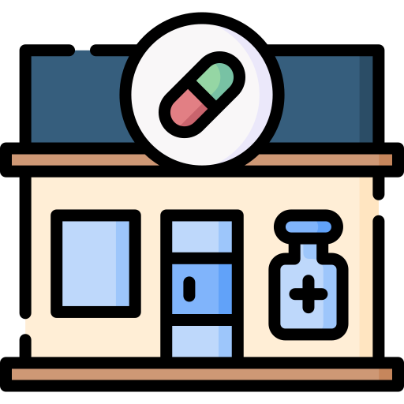

Friends and Family
Friends and Family Feedback Thank you to everyone who has completed a Friends and Family Test (FFT) Survey recently. Patients who are signed up to receive appointment reminders will receive an SMS following their appointment giving them the opportunity to complete the survey. Alternatively, this can be completed online via our website, or we have paper copies of the survey at reception which can be posted in our Friends and Family Box in Waiting Area. The FFT is a valuable tool to enable us to see when we are getting things right and equally highlights areas where improvement is needed. We read all your comments every month and take your suggestions seriously. The high percentage of positive comments are greatly uplifting for the team. To give you an idea of how representative the survey is, it was completed voluntarily by patients monthly. You can complete the survey at any time via our website, patients who have opted for appointment reminders, will receive a text message after their appointment giving them the opportunity to complete the survey

Safer Working Guidance from the BMA  In July, family doctors across England voted to take Collective Action for the first time in 60 years to address the growing challenges in general practice. Our goal is to protect patient care and ensure safe working conditions for GPs and their teams.  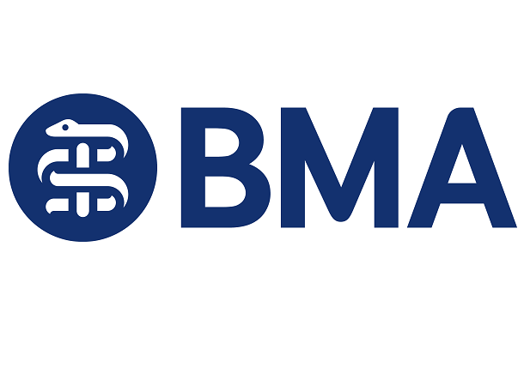  Why Collective Action is Necessary  General practice faces an overwhelming demand. GPs see almost half the population every month, often pushing beyond their capacity in an attempt to keep up. This is not only unsustainable but also compromises patient safety. According to the British Medical Association (BMA), the situation has reached a crisis point, with general practice facing an ever-increasing workload, worsened by the pandemic’s backlog of care and a diminishing workforce. Years of underinvestment, along with additional responsibilities passed on from hospitals, have put an unbearable strain on practices. In light of this, 98.3% of GPs voted to take immediate action to safeguard their ability to deliver safe and high-quality care for their patients.  Shifting Hospital Responsibilities Back to Where They Belong  A key part of Collective Action is reducing the extra work passed to GPs that hospitals should handle, allowing us to focus on the services we are contracted to deliver.  Examples of Tasks Hospitals Should Manage:  - Sick Notes: Hospitals should issue sick notes for admissions, not your GP.  - Test Results: Hospitals are responsible for providing test results, not GPs.  - Medications After Discharge: Hospitals should supply a complete course of medications, like eye drops after cataract surgery.  Freeing GPs from these tasks could increase our capacity by 20%, allowing more time to provide appointment slots and focus on essential services for you   |  | Practice News  RSV Vaccination Programme    Practice News: RSV Vaccination Programme Respiratory syncytial virus (RSV) is a common winter virus that causes colds and coughs. While it often leads to mild illness, it can result in severe respiratory issues like bronchiolitis and pneumonia, especially in infants under 6 months and the elderly. RSV accounts for around 500 deaths and 15,000 GP appointments annually in the UK.  From 1st September 2024, two new RSV vaccination programs will be introduced:  - For adults aged 75-79: Adults turning 75 on or after 1st September 2024 will be eligible for a routine RSV vaccine. A one-off catch-up programme will also be offered for those already aged 75-79 by this date.  - For pregnant women: Women who are at least 28 weeks pregnant by 1st September 2024 will be offered the vaccine to protect their infants. After this, women will become eligible for the vaccine as they reach 28 weeks of pregnancy and remain eligible until birth.  Most pregnant women will receive the vaccine from their midwife, but it can also be administered at the practice if needed. RSV vaccines should not be given alongside Flu or Covid-19 vaccines, but they can be safely combined with the Pneumonia or Shingles vaccine.
Changes You May Experience  We are following the British Medical Association’s (BMA) Safer Working Guidance to ensure we provide safe and effective care.  Each doctor will now handle a limit of 30 appointments per day, most of which will be both face-to-face, Telephone and Admin. These appointments will be 10 minutes long to do both consultation and administration. This ensures better care and helps prevent burnout.  When we reach our daily capacity. Our reception team will ask questions to guide you to the most appropriate service, such as your GP, a pharmacy, or NHS 111. | 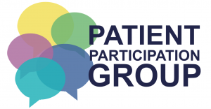  Patient Participation Group  Join your PPG.  - Share your view.  - Achieve Change!  - Improve your service.  To support the surgery and its patients the PPG always needs new members. Join us as an ACTIVE member (attending meetings in person) or as a VIRTUAL member via email. If you can’t (attend meetings in person)  TO FIND OUT MORE PLEASE CONTACT: Tina Kitto is the admin persons.  Email: enquiries.wmp@nhs.net  Our next meeting will be 14th November’24

