BY FLORENCE ADEWUNMI
  We would like to wish all our patients a very merry Christmas and a very Happy & Health New Year.  Welling Medical Practice Newsletter Christmas  The practice will not have a walk-in clinic on the following dates:  - 23rd December 2024  - 30th December 2024  The practice will be closed on:  - 25th December 2024  - 26th December 2024  - 1st January 2025  Did you know you can find your nearest pharmacy’s opening times, including those offering contraception without a prescription, free blood pressure checks, or COVID-19 rapid lateral flow tests, on NHS Choices?  Visit https://www.nhs.uk/nhs-services/pharmacies/. | Download the NHS App for proxy ACESS 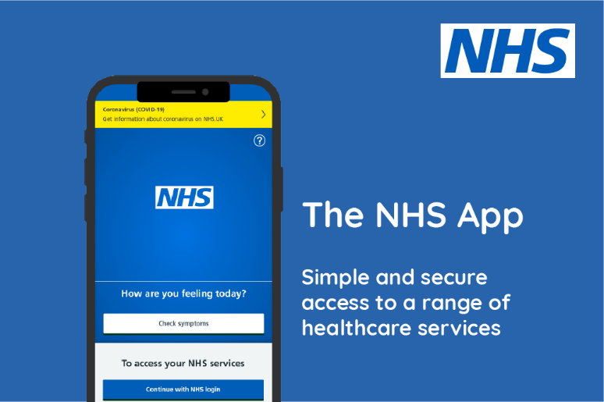  NHS App – Proxy Access for Your Loved On…. You can use the NHS App to manage the healthcare of your loved ones? With proxy access, you can order prescriptions and view medical records for those you care for. Keep on top of their health with ease!  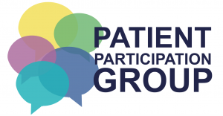  Patient Participation Group  Join your PPG.  - Share your view.  - Achieve Change!  - Improve your service.  To support the surgery and its patients the PPG always needs new members. Join us as an ACTIVE member (attending meetings in person) or as a VIRTUAL member via email. If you can’t (attend meetings in person)  TO FIND OUT MORE PLEASE CONTACT: Tina Lowe is the admin persons.  Email: enquiries.wmp@nhs.net  Our next meeting will be 9th January’25

Friends and Family
Friends and Family Feedback Thank you to everyone who has completed a Friends and Family Test (FFT) Survey recently. Patients who are signed up to receive appointment reminders will receive an SMS following their appointment giving them the opportunity to complete the survey. Alternatively, this can be completed online via our website, or we have paper copies of the survey at reception which can be posted in our Friends and Family Box in Waiting Area.
The FFT is a valuable tool to enable us to see when we are getting things right and equally highlights areas where improvement is needed. We read all your comments every month and take your suggestions seriously. The high percentage of positive comments are greatly uplifting for the team. To give you an idea of how representative the survey is, it was completed voluntarily by patients monthly. You can complete the survey at any time via our website, patients who have opted for appointment reminders, will receive a text message after their appointment giving them the opportunity to complete the survey. The data report from the survey.
FFT DATA for Novermber’24 is Very Good comments are 21 and Good comments are 10

Bowel Cancer Screening Programme –  52-year-olds The age of eligibility for participating in the NHS Bowel Cancer Screening Programme, now includes 52-year-olds, alongside 54, 56- and 58-year-olds, as part of age expansion of the programme. This will support the national priority of improving earlier diagnosis by 2028. Age extension will conclude by including 50-year-olds in March 2025.  The Bowel Cancer Screening System (BCSS) began sending invitations to 52-year-olds at the beginning of September 2024.  - Invitations are being sent to 52-year-olds in the borough of Bexley, Bromley, Greenwich, and Lewisham to participate in the NHS Bowel Cancer Screening Programme.  - Some 52-year-olds may not be aware they are now eligible to participate in the screening programme and make contact for further information.  - Kindly provide brief information about bowel screening and guidance on how to complete the test kit.  For support wth any queries, please contact the Lewisham and Greenwich NHS Trust Bowel Cancer Screening Centre:  Email: lh.bcs@nhs.net | Tel: 020 8333 3038 |  | Appointments DNA  We aspire to offer routine appointments with a doctor and nurse, but during busy periods, this may not always be possible. Our receptionists will always do their best to accommodate your request, so please be understanding.  If you are unable to keep your appointment, please let us know as wasted appointments mean longer waiting times for others.  Appointments Statistics – November 2024  - 3,715 appointments booked during November 2024.  - 210 appointments were missed by patients who failed to attend.  - 504 appointments used for Admin consulting time.  - 4,429 total appointments offered in November
Changes You May Experience  We are following the British Medical Association’s (BMA) Safer Working Guidance to ensure we provide safe and effective care.  Each doctor will now handle a limit of 30 appointments per day, most of which will be both face-to-face, Telephone and Admin. These appointments will be 10 minutes long to do both consultation and administration. This ensures better care and helps prevent burnout.  When we reach our daily capacity. Our reception team will ask questions to guide you to the most appropriate service, such as your GP, a pharmacy, or NHS 111. | The practice supports the Government’s Zero Tolerance campaign.  Abusive or threating behavior towards any member of the practice Team or any other person present on the premises., will be taken very seriously and the police will be notified, if necessary. This may result in your removal from the practice list.  